Anna Jarstad
Uppsala University

Varieties of Peace:
How to conceptualize and study peace.

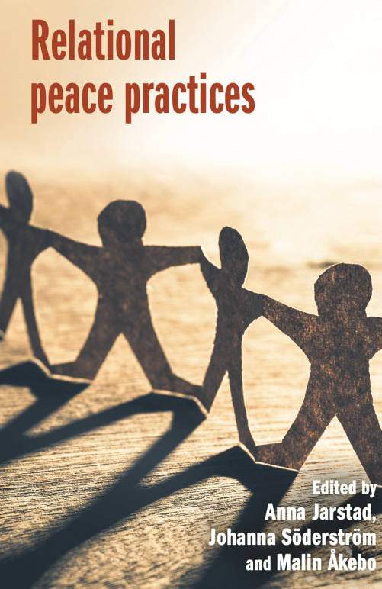

Discussant: Roberto Belloni, University of Trento
Local organizer: Francesco N. Moro

Aula Jemolo
November 22nd, 2022
5:00pm

